Sliding Window Blockchain Architecture for Internet of Things

In this paper author is describing concept to provide security to IOT devices using Blockchain technology as this technology supports decentralized data storage which means data will be stored at multiple nodes compare to centralized storage where data is stored at single centralized server. Decentralized data storage provides facility of receiving data from any available node and it has strong security where a single data store will verify hash value of all nodes. Verification of all nodes hash is computation intensive and its cannot be applied to IOT small devices due to memory, CPU and energy consumption restrictions.

To overcome from this problem author introduce Sliding window technique where the window size will be fixed and all Blockchain transaction hash values will be stored in window and if window size exceeded then old transaction blocks will be slided or removed and maintain only recent blocks due to this technique memory storage and data transfer overhead will be reduced.

In extension author is saying to further save energy so I am adding concept of monitoring data in time interval and if sensor generate same random data within time interval then IOT will not process that data to store in Blockchain and this duplicate avoidance can further save energy.

In this paper author is using sensor and other devices for implementation but we don’t have any devices or sensors so I implement this project as simulation.

Below screen shot of code showing how encryption and block chain hash generation take place

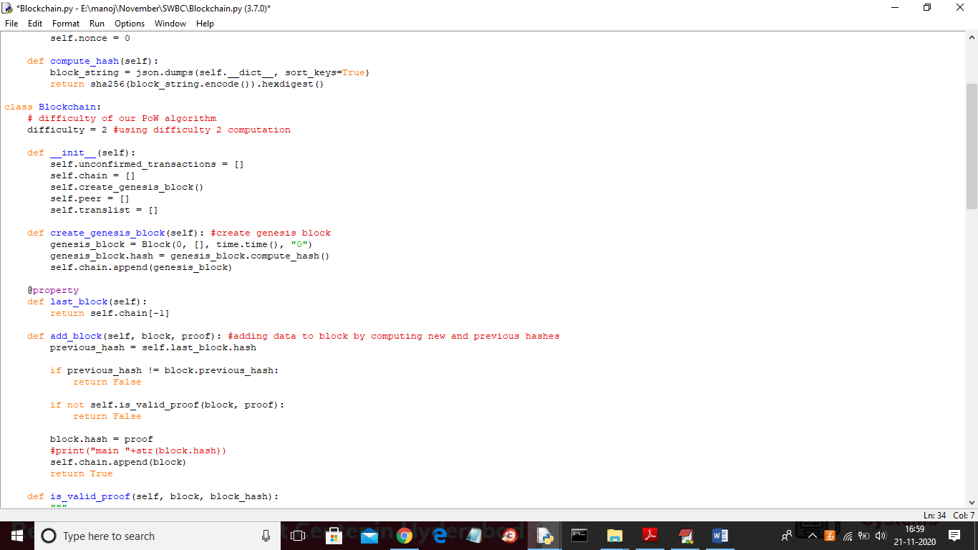

In above screen read comment to understand block chain algorithm of generating hash value and storage

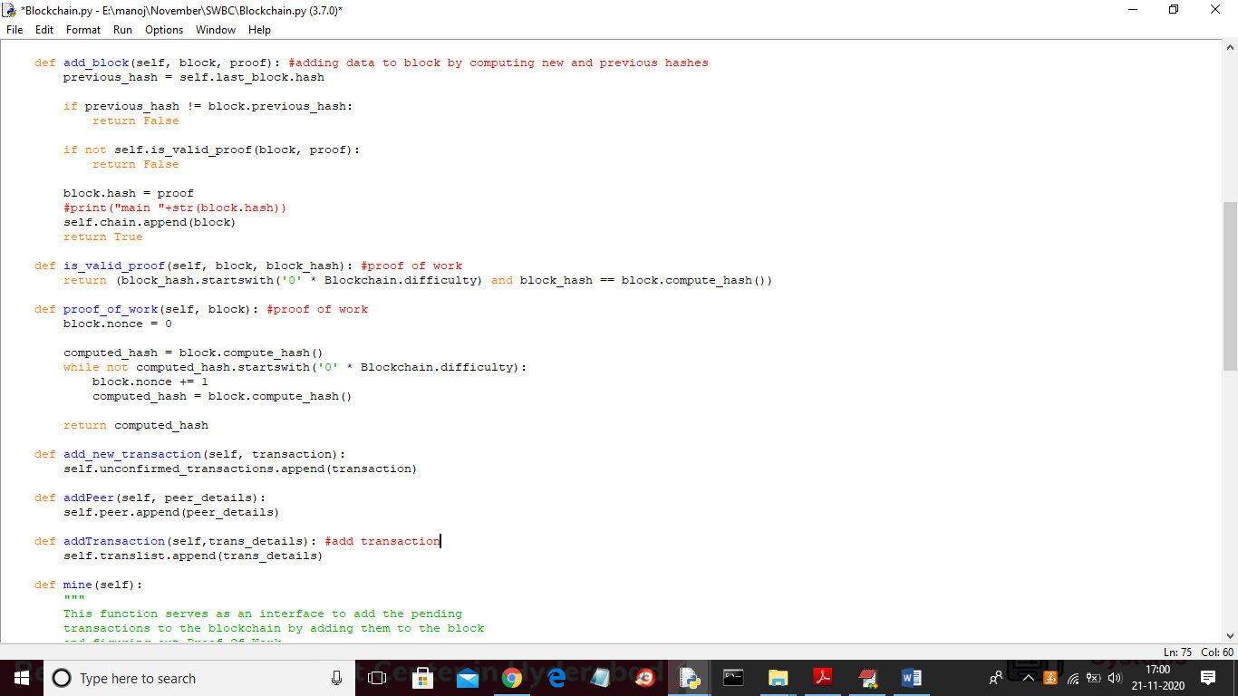

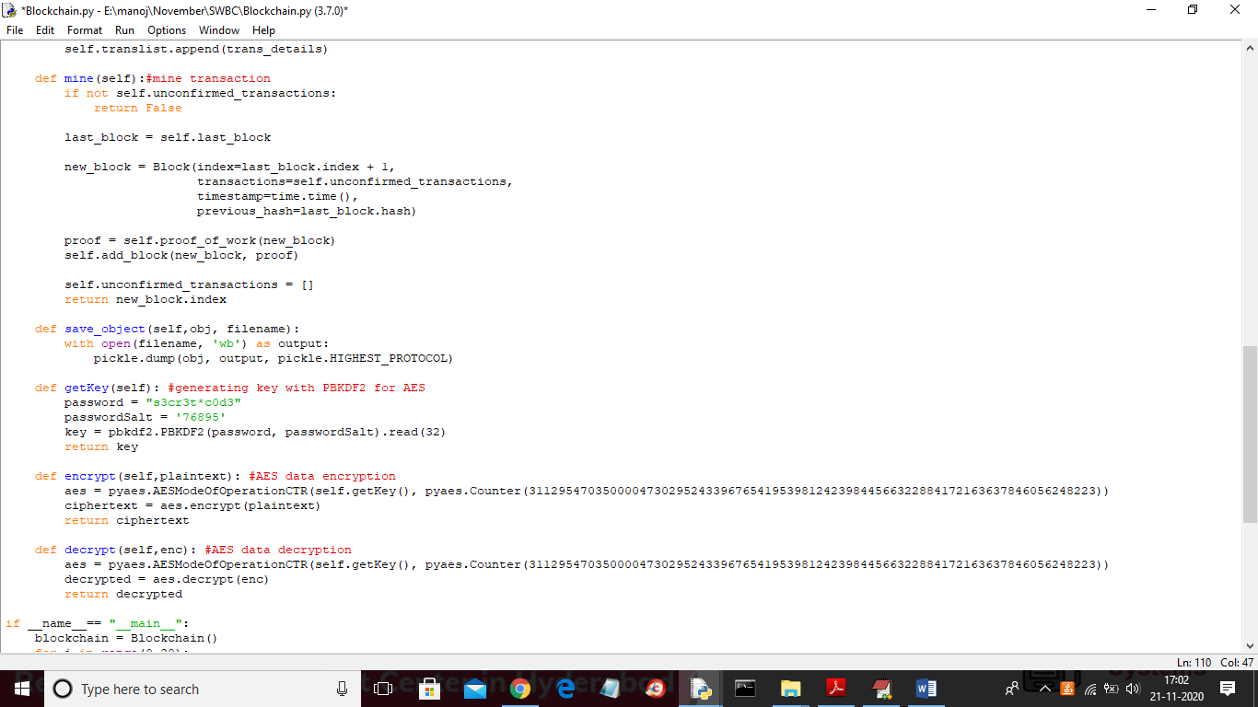

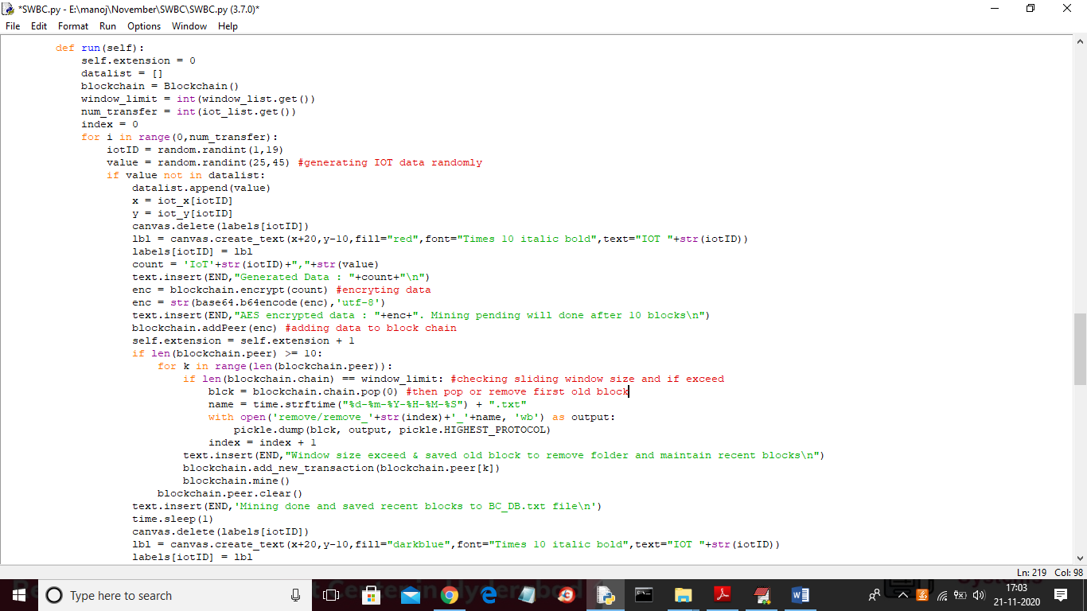

Output SCREENS

To run project double click on ‘run.bat’ file to get below screen

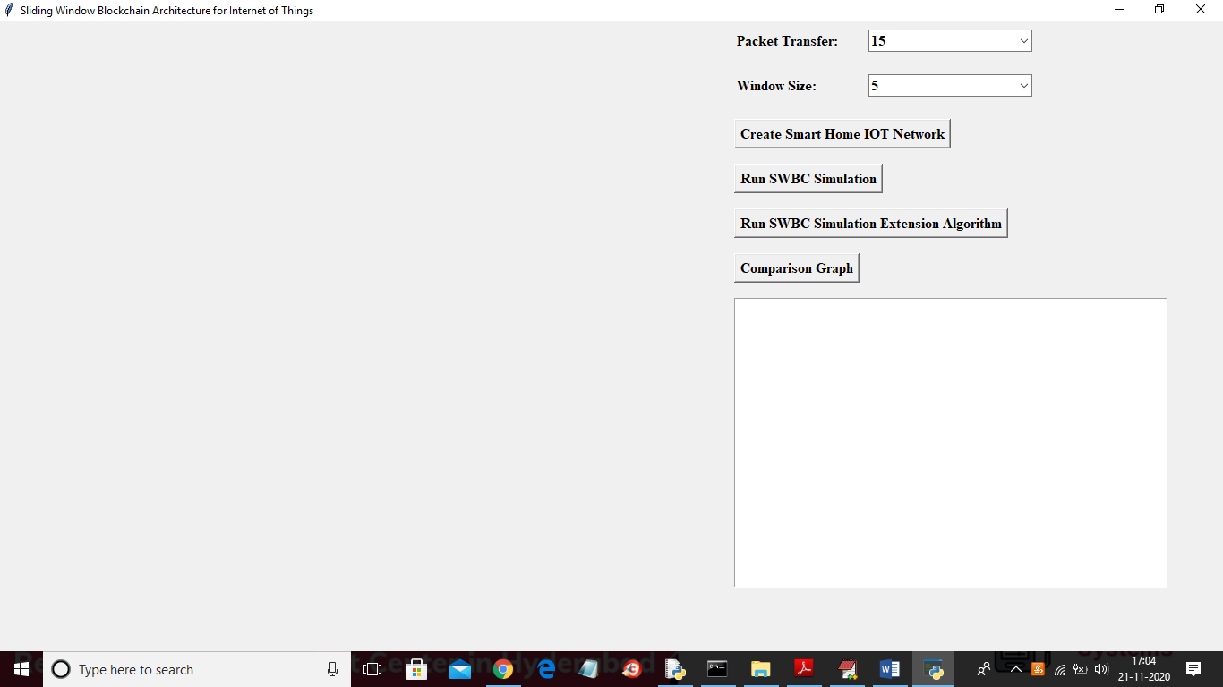

In above screen select number of packet transfer and then select window size as 5, 10 or 15 and then click on ‘Create Smart Home IOT Network’ button to get below screen

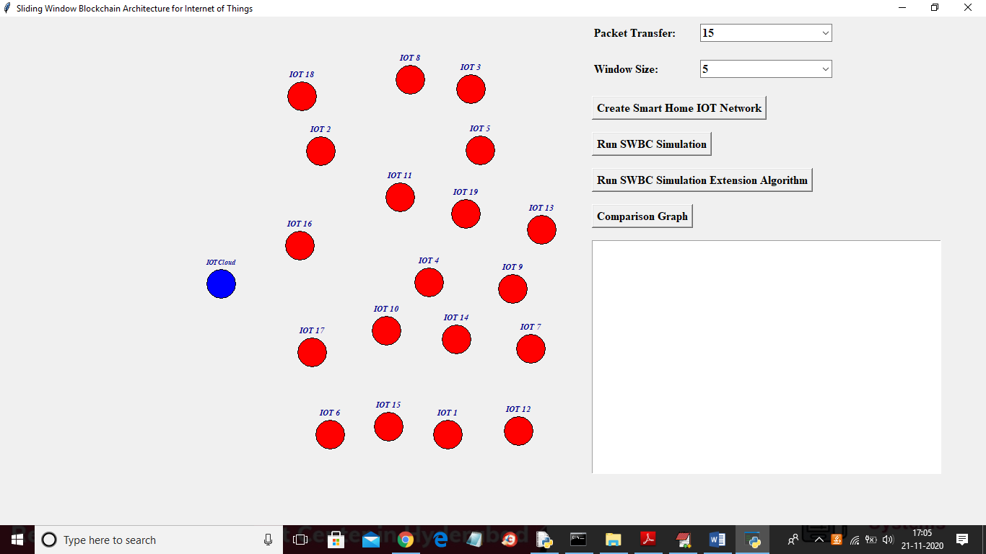

In above screen I selected number of packet transfer as 15 and window size is 5 and block chain can store data up to 5 blocks and if exceed then old block remove out and send to cloud for storage and new block will store in IOT memory. In above screen all red colour circles are home IOT and blue colour circle is the IOT cloud which will receive data from IOT upon IOT window full. Now click on ‘Run SWBC Simulation’ button to allow each circle to sense data randomly and while sensing circle label will change to red colour

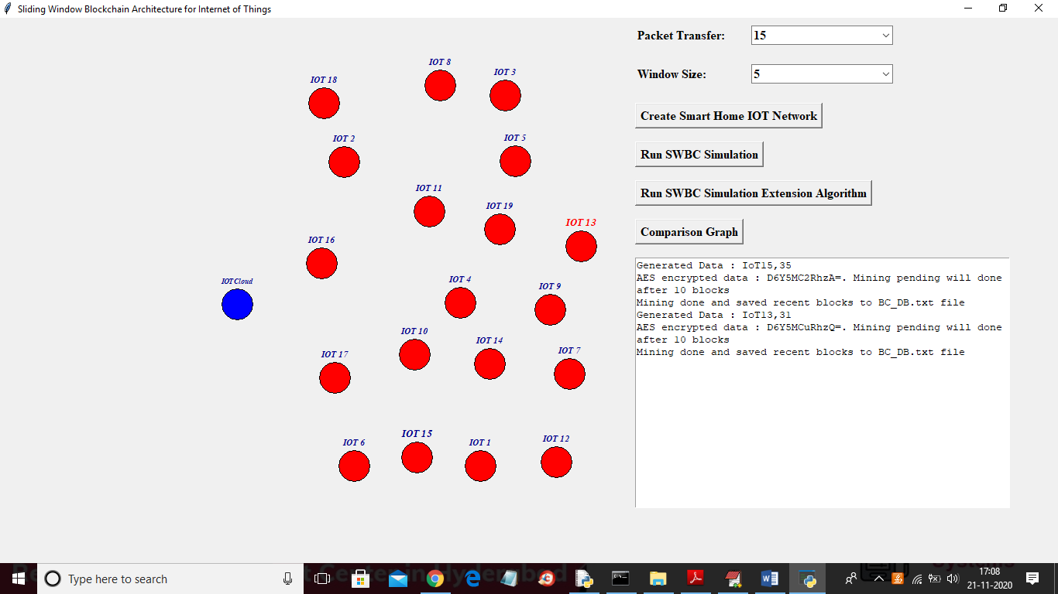

In above screen IOT13 label is sensing data and its label colour change to red colour and this simulation will run for 15 packets transfer and for each transfer sensor will be chosen randomly. In text area we can see which IOT is sensing data and its sense value separated by comma symbol. In next line displaying AES encrypted data and then displaying mining is done or not and after simulation will get below screen

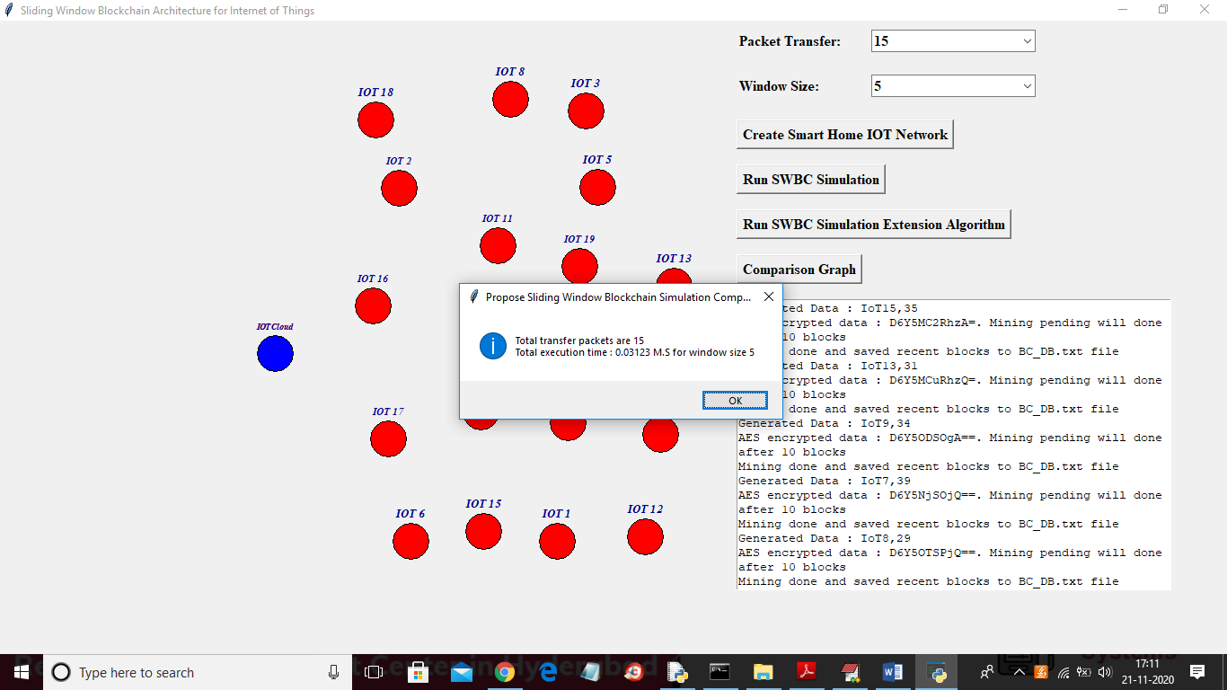

In above screen after sending packets we will get above dialog box with total packets sense and send and it will display how much time it took to process that window size 5 and displaying total sense and send packets as 15. In below screen we can see latest recent blocks store at IOT memory

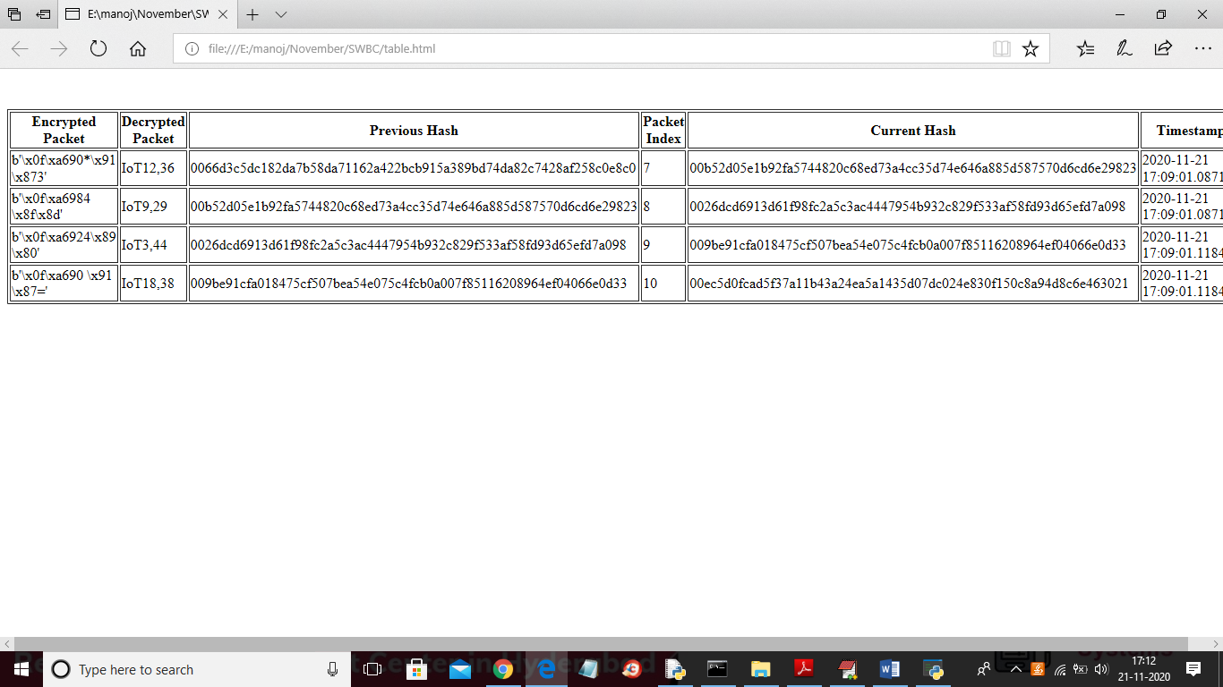

In above screen as our window size was 5 and first block is empty for genesis and latest 4 records of IOT are displaying and in above screen in first column showing encrypted data then in second column decrypted data and then showing previous hash value and then block chain index value and then current hash value with time. In above screen we can see that block chain verify previous and current hash value. In above screen we can see current hash of first row is matched with previous hash of second row. In above screen with propose work we sense and store 15 packets and sometime IOT sensor will sense same data as temperature will not change for some intervals and if we send same data again and again then it waste processing time and increase overhead. We can avoid this overhead by monitoring data and If same data generate again then we will not process in extension work. Now click on ‘Run SWBC Simulation Extension Algorithm’ button to avoid duplicate processing

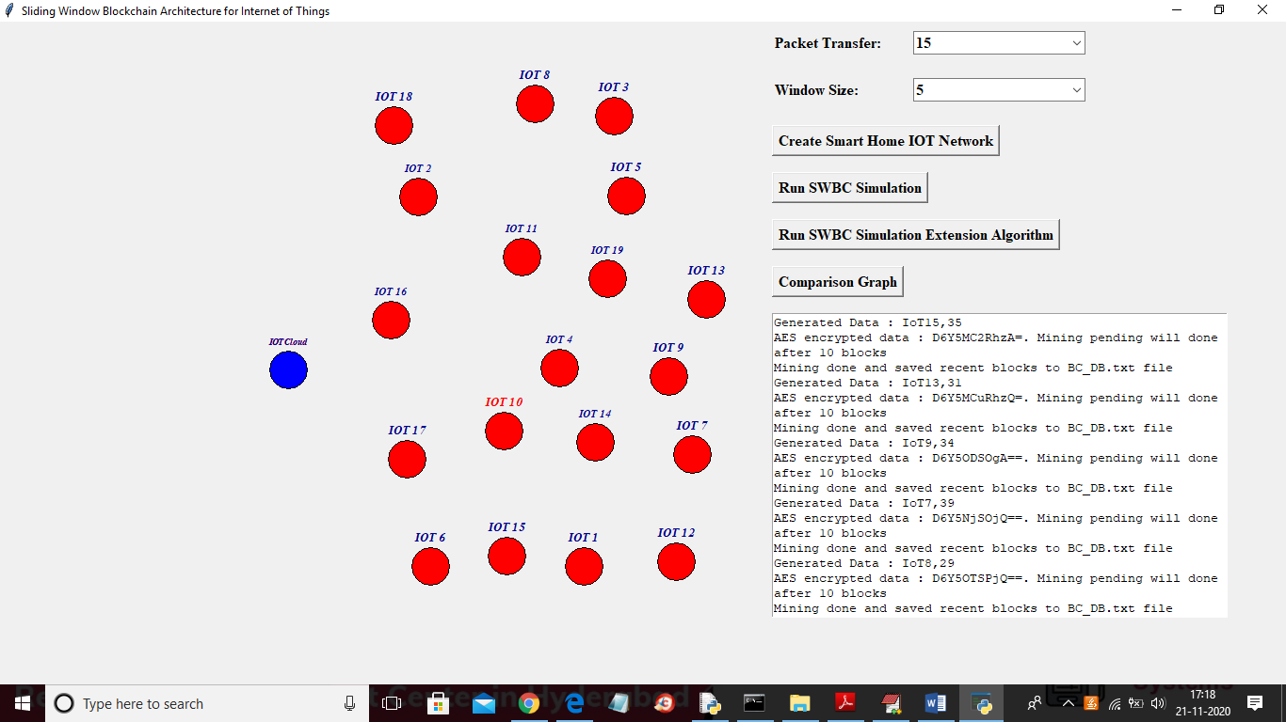

In above screen also IOT start sensing and sending packets and in above screen IOT10 is changed to red colour which means its sensing and sending data and after all 15 packets transfer will get below screen

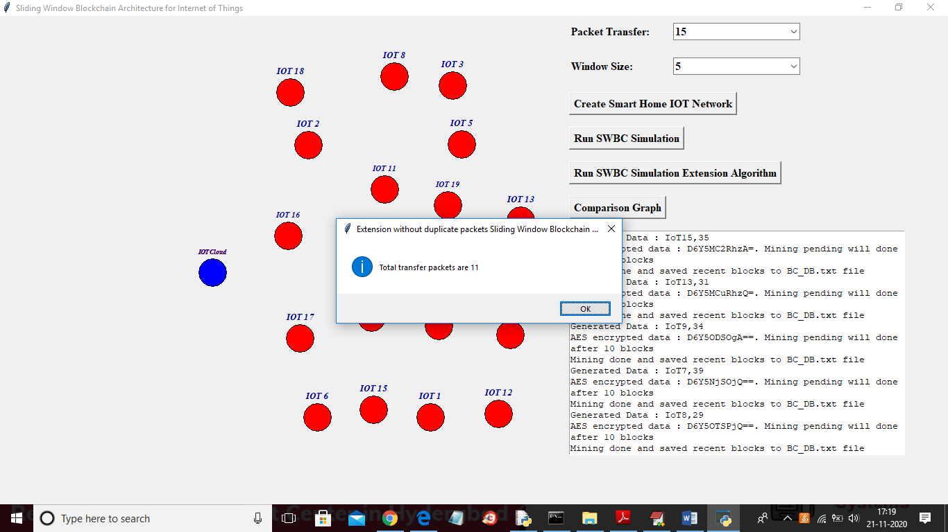

In above screen with extension work from 15 packets we process only 11 packets and 4 duplicate packets avoided and this 4 packets energy consumption will be saved. Now click on ‘Comparison Graph’ button to get below graph

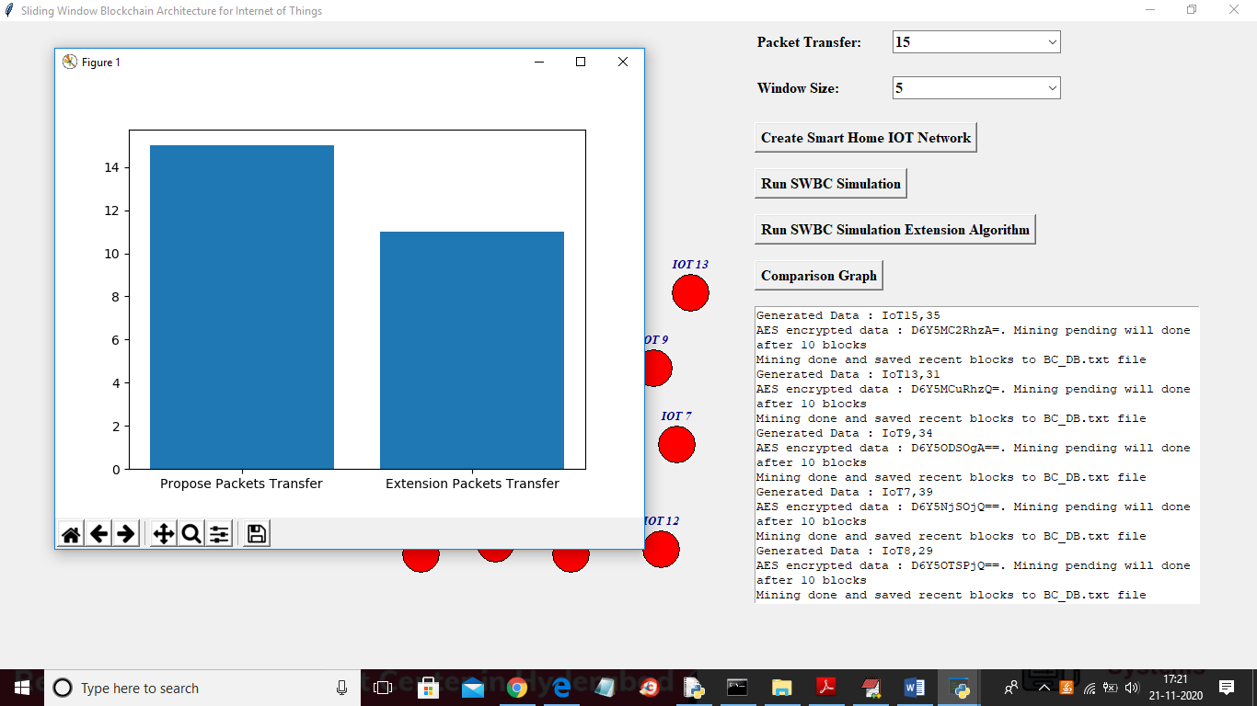

In above graph x-axis represents algorithm name and y-axis represents number of packets transfer and with extension work application process only 11 packets and can save energy of 4 packets.